Semester Two Examination, 2018

Question/Answer booklet

MATHEMATICS SPECIALIST
UNITs 3 & 4

Section Two:

Calculator-assumed

Your Name

Your Teacher’s Name

Time allowed for this section
Reading time before commencing work: ten minutes
Working time: one hundred minutes

Materials required/recommended for this section
To be provided by the supervisor
This Question/Answer booklet
Formula sheet (retained from Section One)

To be provided by the candidate
Standard items: pens (blue/black preferred), pencils (including coloured), sharpener, correction fluid/tape, eraser, ruler, highlighters

Special items: drawing instruments, templates, notes on two unfolded sheets of A4 paper, and up to three calculators approved for use in this examination

Important note to candidates
No other items may be taken into the examination room. It is your responsibility to ensure that you do not have any unauthorised material. If you have any unauthorised material with you, hand it to the supervisor before reading any further.

Structure of this paper

Section | Number of questions available | Number of questions to be answered | Working time (minutes) | Marks available | Percentage of examination
Section One:  Calculator-free | 8 | 8 | 50 | 51 | 35
Section Two:  Calculator-assumed | 12 | 12 | 100 | 100 | 65
 |  |  |  | Total | 100

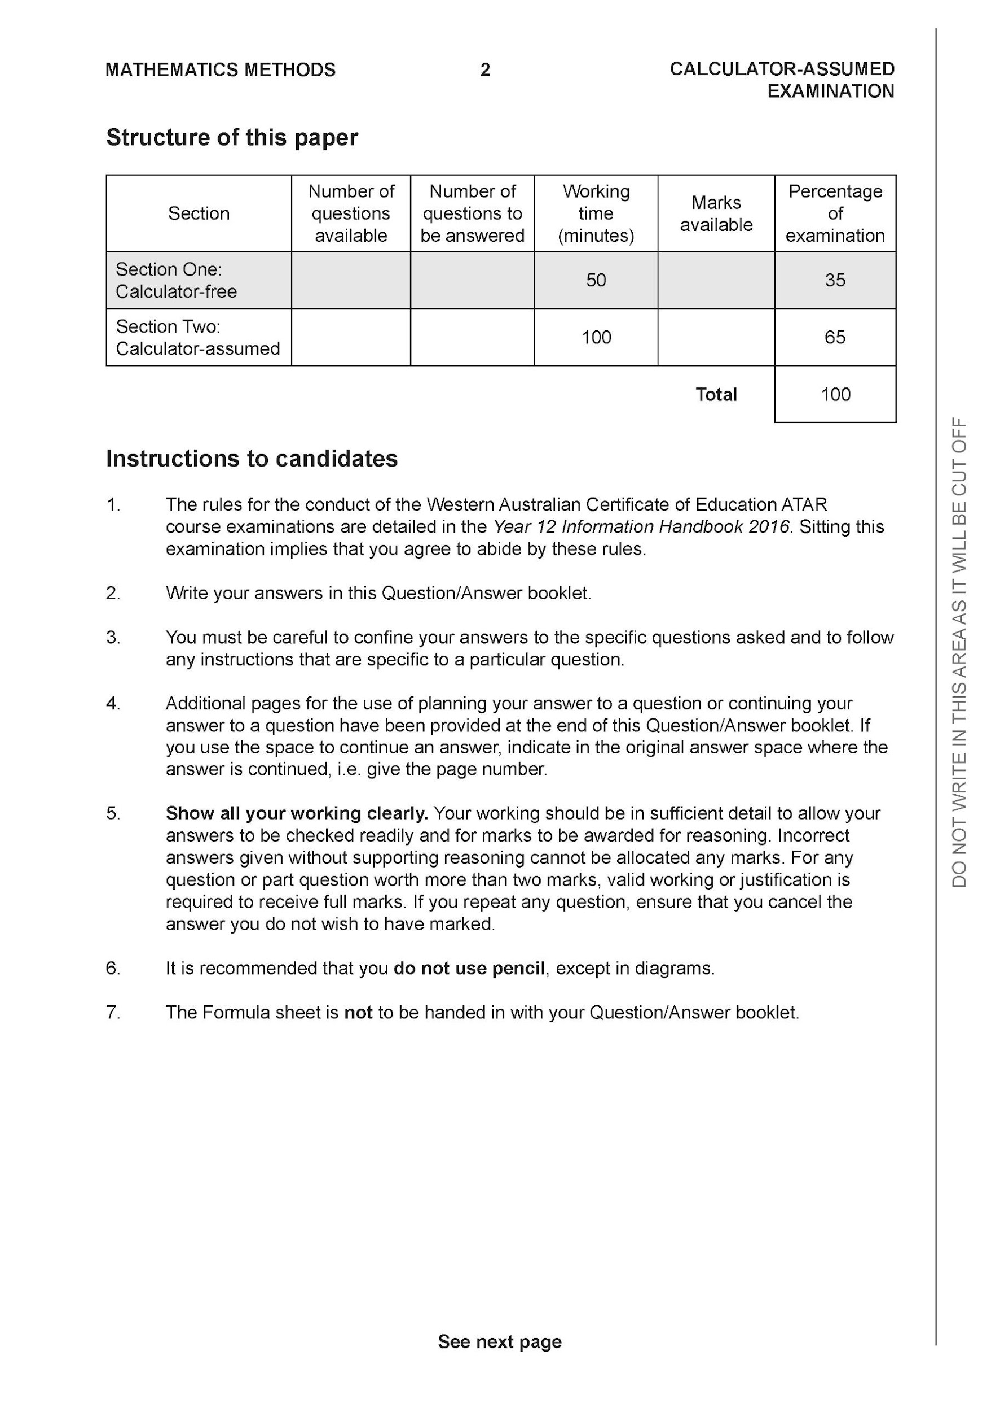

Section Two: Calculator-assumed (100 Marks)

This section has 12 questions. Answer all questions. Write your answers in the spaces provided.

Spare pages are included at the end of this booklet. They can be used for planning your responses and/or as additional space if required to continue an answer.
● Planning: If you use the spare pages for planning, indicate this clearly at the top of the page.
● Continuing an answer: If you need to use the space to continue an answer, indicate in the original answer space where the answer is continued, i.e. give the page number. Fill in the number of the question that you are continuing to answer at the top of the page.

Working time: 100 minutes.

Question 9 (6 marks)

For a brand of Marvel breakfast cereal the weight of cereal in packets that claim to contain
750grams is actually normally distributed with a mean of 758 grams and standard deviation 5
grams.

(a) What percentage of cereal packets will be under the stated weight? (2 marks)

Solution
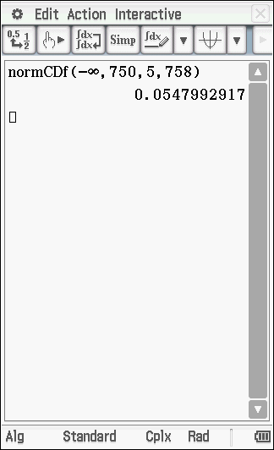
Percentage of 5.47%

Specific behaviours
✓ determines probability
✓ states percentage

(b) A random sample of 15 packets is selected and the sample mean is taken. What is the probability that the sample mean of these 15 packets is 760 grams when rounded to the nearest gram?
(2 marks)

Solution
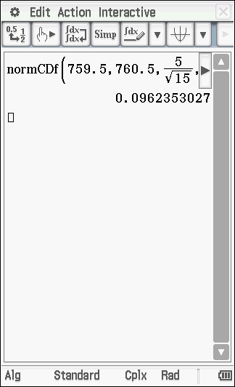

Specific behaviours
✓ determines standard deviation of sample mean
✓ determines probability

(c) The confidence interval was obtained for a sample of 15 packets. Determine the level of confidence to 0.1%. (2 marks)

Solution
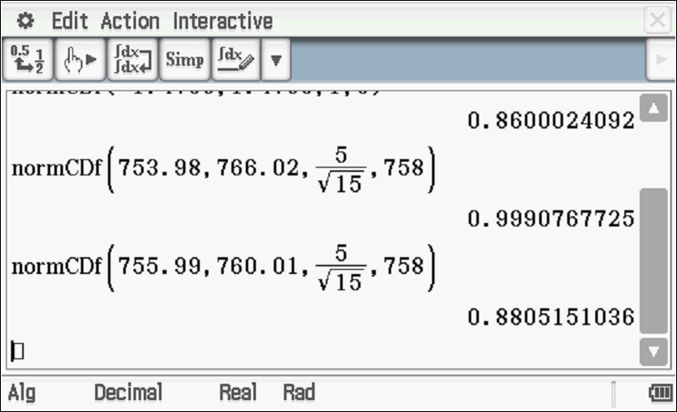

Specific behaviours
✓ determines probability between limits
✓ rounds to nearest 0.1%

Question 10 (9 marks)

- Determine all the roots of the equation , expressing them all in polar form with and
(3 marks)

Solution
Specific behaviours
✓ uses De Moirves theorem
✓ determines four independent roots
✓ uses principal argument for all roots

(b) Plot all of the above roots on the diagram below. (3 marks)

Solution
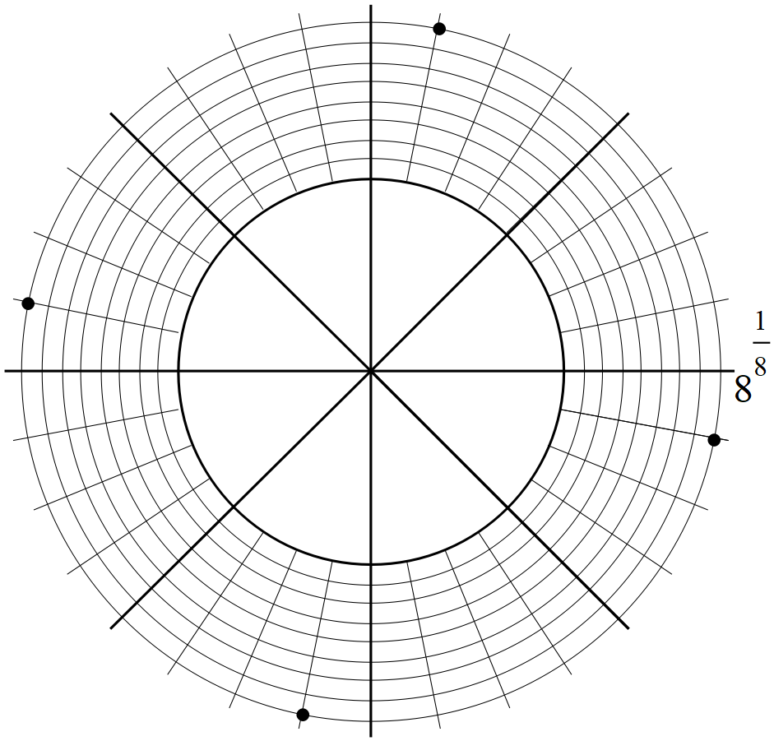

Specific behaviours
✓ scale given for modulous
✓ equally spaced points
✓ accuracy

(c) Consider the roots in the first and second quadrants. Determine in polar form,
the midpoint of the line joining these two roots..
(3 marks)
Solution
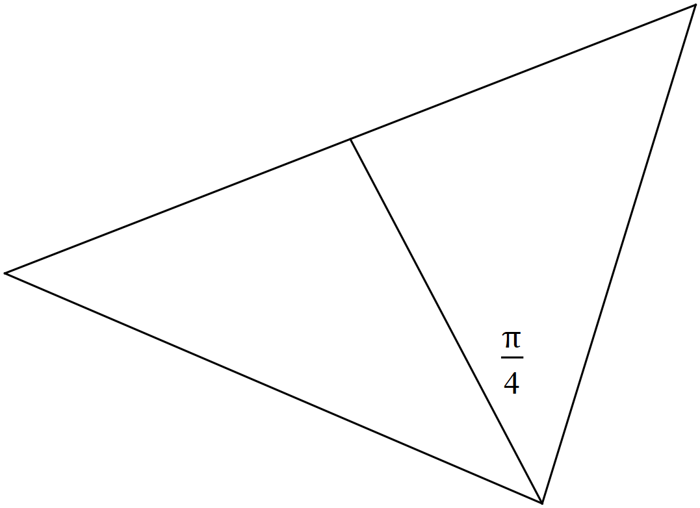

Specific behaviours
✓ uses a right angle triangle
✓determines exact modulus of midpoint
✓determines exact argument of modulus

Question 11 (8 marks)

The slope field is plotted below for
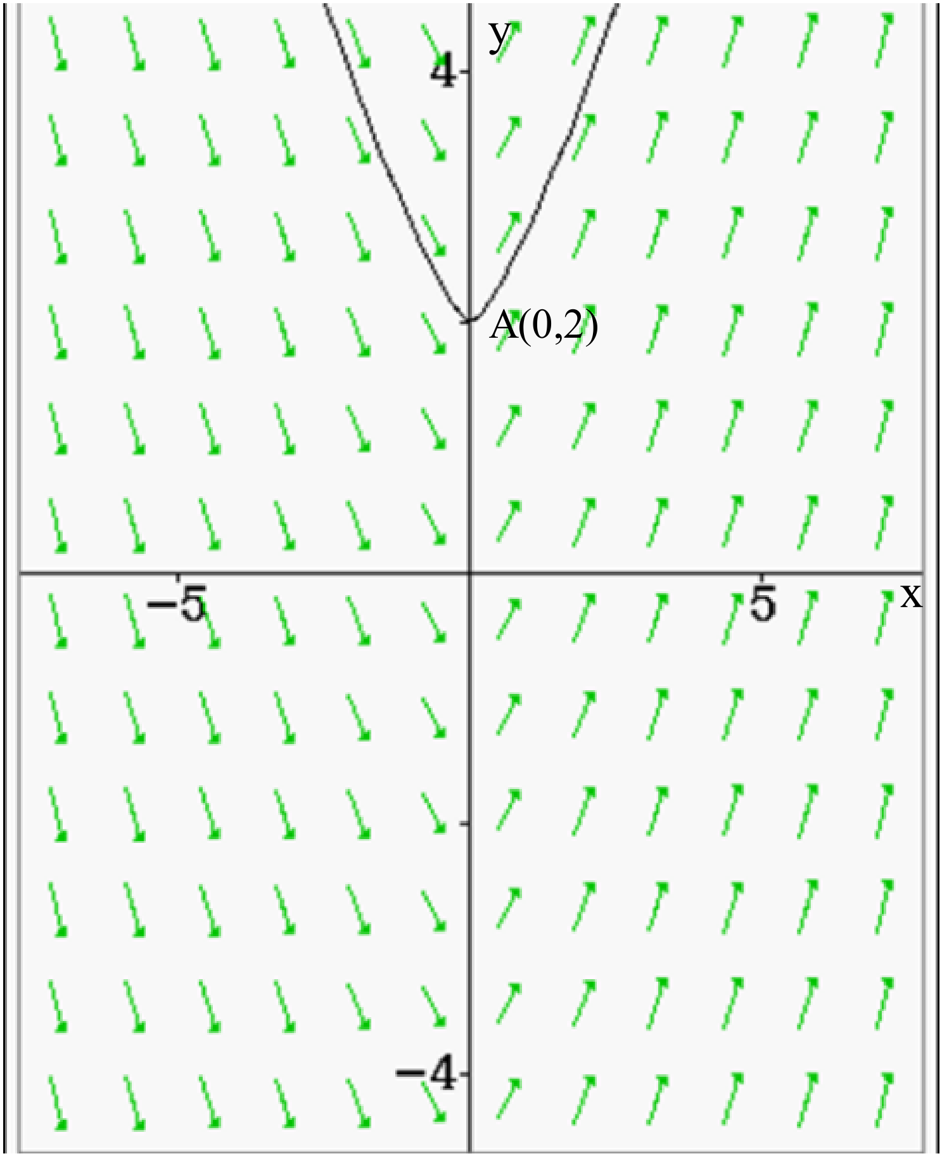

(a) Determine the value of the slope field at point (2 marks)

Solution
Specific behaviours
✓ uses x=0
✓ states slope field of zero

(b) Determine the equation for the line of force that passes through point
(3 marks)
Solution
Specific behaviours
✓ integrates correctly
✓ uses a constant
✓ states line of force through pt A

Q11 cont-
(c) Sketch the slope field for on the diagram below. (3 marks)

Solution
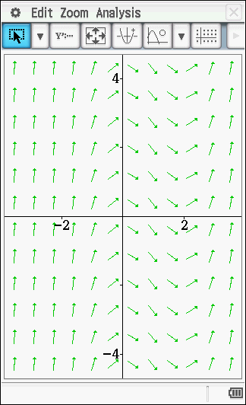

Specific behaviours
✓ shows horizontal slopes for x=0
✓ shows horizontal slopes for x=2
✓ shows slopes becoming closer to vertical at both extremes

Question 12 (6 marks)

A solid sphere of radius 5 cm has a hole drilled through the centre with a diameter of 2 cm. See diagram below. Determine the volume of the remaining solid

Solution
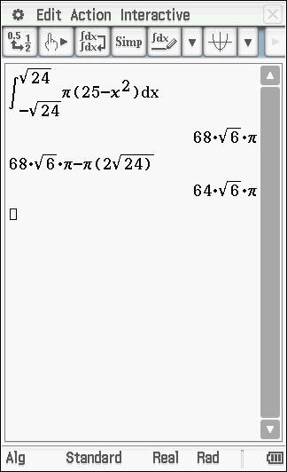

Specific behaviours
✓ determines x intercepts when y=1
✓ uses volume of revolution integral
✓ uses correct limits on integral which is linked to x intercepts when y=1
✓ states result for integral with correct method
✓ subtracts hollow cylinder of diameter 2 cm. and correct length
✓gives exact value for remaining volume with correct method
OR
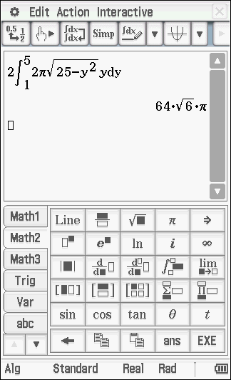
✓ determines y intercepts
✓ uses alternative volume of revolution integral
✓ doubles the x variable
✓ states result for integral with correct method
✓ subs correct value for y with dy around x axis
✓gives exact value for remaining volume with correct method

Question 13 (7 marks)

Consider the ellipse which contains the point

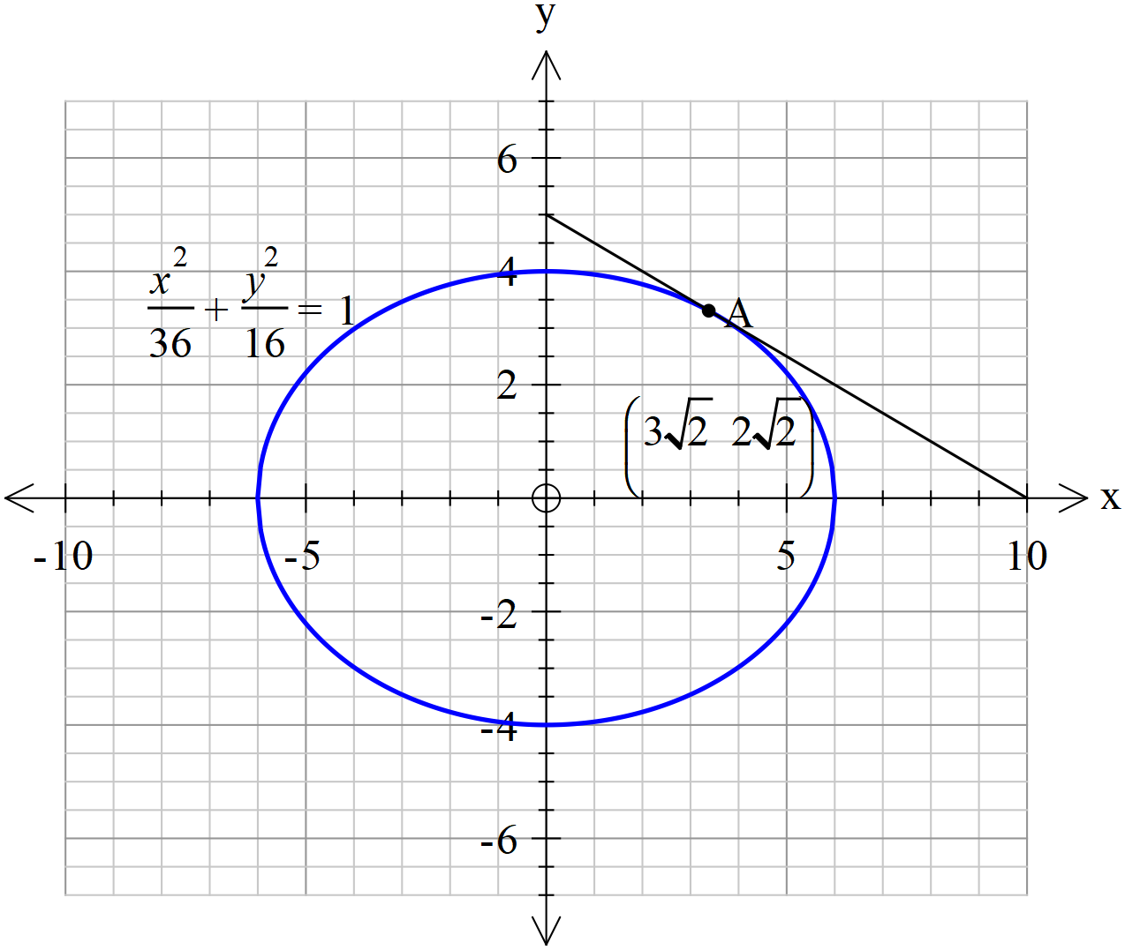
(Note- tangent line is not drawn to scale)

- Determine the equation of the tangent to the ellipse at point A. (4 marks)

Solution
Specific behaviours
✓ uses implicit diff
✓ subs coordinates to find gradient at point A
✓ solves for constant for tangent line
✓ states equation of tangent line

- Determine the area that is bound between the y axis, ellipse and the tangent line at A above to two decimal places. (3 marks0
- Solution
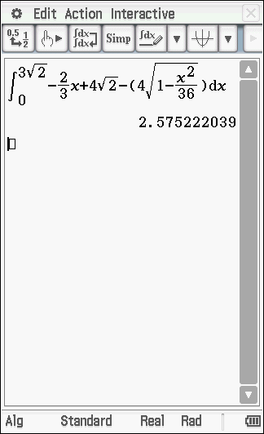

Approx. 2.58

Specific behaviours
✓ sets up integral
✓ uses appropriate limits
✓ determines approx. area

Question 14 (11 marks)

The working length of an electric cell is found to be Normally distributed. A sample of 20 such electric cells were found to have a sample mean of 1138 working hours and a sample deviation of 250 hours.. The customer needs to purchase electric cells that will have a mean working time in excess of 1250 hours.

- Determine a 95% confidence interval for the population mean working time to two decimal places. (4 marks)
Solution
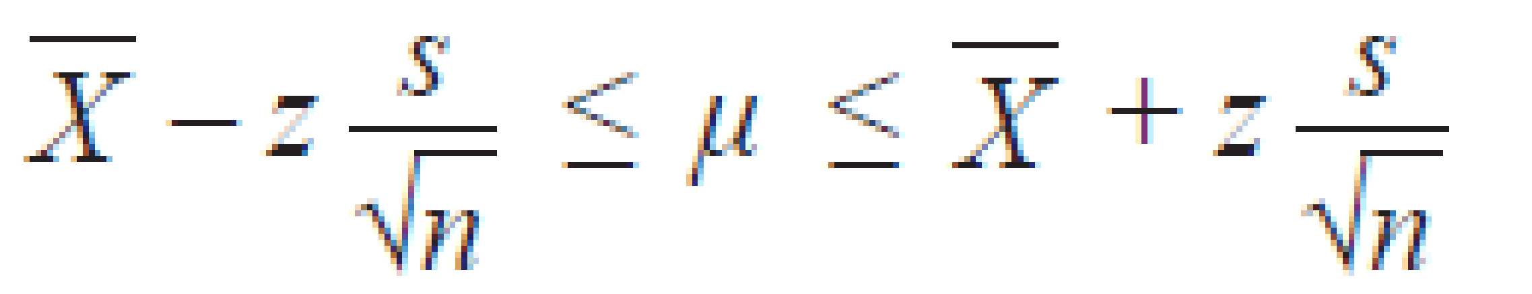

Specific behaviours
✓ states use of z score 1.960
✓ uses correct standard deviation for sample mean
✓ states lower and upper limits
✓ rounds to 2 decimal places

- Should the customer buy this type of electric cells? Justify your answer. (2 marks)
Solution
No as the required mean is greater than upper limit of confidence interval.

Specific behaviours
✓ states No
✓ gives reason using confidence interval

- If a single cell was selected, would you expect the working time to lie in the confidence interval in part a above? Explain. (2 marks)
No as a single result is random and the confidence interval relates to sample mean, not an individual result for X.

Specific behaviours
✓ States No
✓ gives reason

- A second sample of cells gave a sample deviation of 250 hours. A 86% confidence interval was calculated to be . Determine the value of . (3 marks)

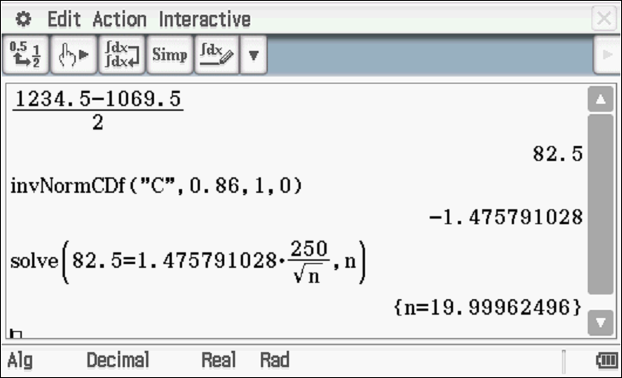
n=20

Specific behaviours
✓ solves for z score
✓ uses sample mean standard deviation
✓ rounds n up

Question 15 (12 marks)

Consider a particle that is projected into the air such that its position vector at any time,
seconds is given by metres.

(a) Determine the exact initial velocity. (2 marks)

Solution
Specific behaviours
✓ diff to find velocity
✓ subs t=0

(b) Determine the time taken to hit the ground and the horizontal distance covered.
(3 marks)

Solution
Specific behaviours
✓ solves for y=o
✓ determines time to hit ground
✓ determines range

(c) Determine when seconds. (4 marks)

Solution
Specific behaviours
✓ uses chain rule to find dy/dx
✓ subs t=2
✓ uses chain rule to find second derivative
✓ states both derivatives at t=2

(d) Determine the total distance travelled through the air to the nearest cm. (3 marks)

Solution
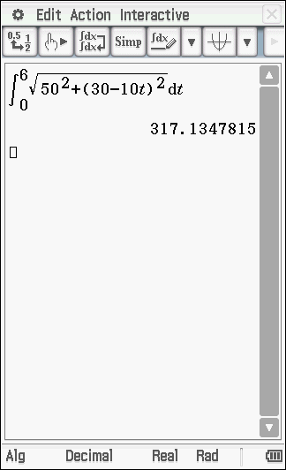
Distance = 317.13 m

Specific behaviours
✓ sets up integral
✓ uses correct time limits with a correct integral
✓ evaluates approx. distance with a correct integral

Question 16 (6 marks)

A boat is moving towards the beach line at metres/minute. On the boat is a rotating light, revolving at 4 revolutions per minute clockwise, as observed from the beach. There is a long straight wall on the beach line, as the boat approaches the beach, the light moves along the wall. Let = the displacement of the light from point on the wall which faces the boat directly. See diagram below.
Determine the velocity, in metres/minute, of the light on the wall when metres and the distance of the boat from the beach, , is 12 metres.

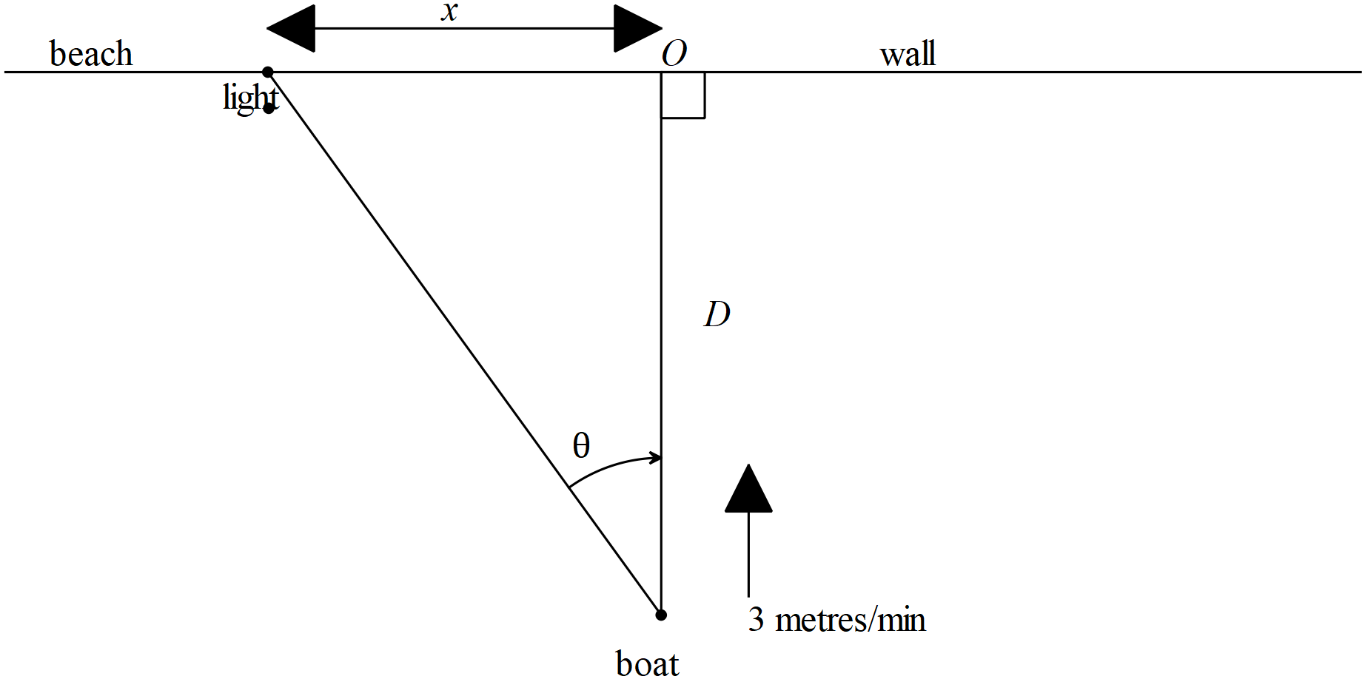

Solution
Metres/min

Specific behaviours
✓ obtains expression for x
✓ uses product rule
✓ obtains time rate of change of angle in radians/min & negative
✓ obtains exact value of cos and tan of angle
✓ uses correct rate for D distance from shore
✓ determines an exact un-simplified expression for velocity in metres per minute

Question 17 (8 marks)

The number of bacterial cells, grams, present in a petri dish in a science lab is given by the logistical growth model , at time hours. The initial number of bacteria cells is 5 grams.

(a) Determine the positive value of where . What does the value represent?
(2 marks)

Solution
Limiting value of N as t approaches infinity

Specific behaviours
✓ states positive value of N
✓ states limiting value of N

(b) By using separation of variables and partial fractions show that . Determine the value of . (4 marks)

Solution
Specific behaviours
✓ uses separation of variables
✓ expresses a quotient as partial fractions with correct coefficients
✓ integrates to obtain an expression for N in terms of t and discusses sign of denominator of partial fractions.
✓ determines the value of constant

(c) Determine the time taken for the number of cells to triple. (2 marks)

Solution
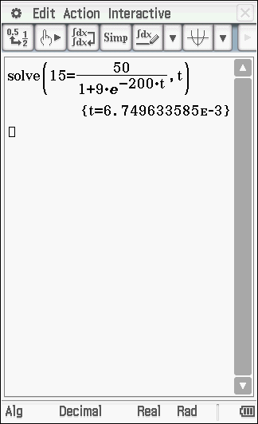

Specific behaviours
✓ uses N=15
✓ solves for time

Question 18 (10 marks)

An object oscillates around a fixed point, such that its displacement from , x metres, is given by at time seconds. The maximum speed is metres/second and is also the initial speed.

(a) Determine the distance from where the speed of the particle will be half of the maximum. (4 marks)

Solution
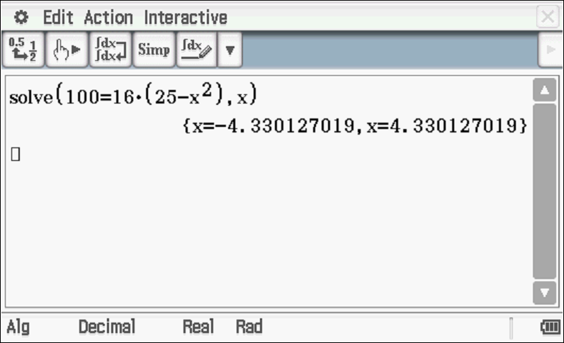

Specific behaviours
✓ identifies value of n
✓ determines Amplitude
✓ uses expression for speed in terms of x
✓ solves for x

(b) Determine the distance travelled by the particle in the first 2 seconds to the nearest cm.
(3 marks)

Solution
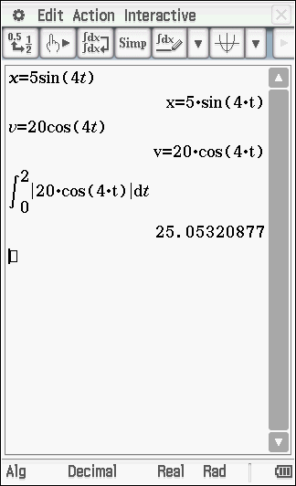

Specific behaviours
✓ uses appropriate function for x and v with correct phase constant
✓ integrates absolute value of velocity
✓ states distance travelled in first two seconds

(c) Determine the percentage of the time that the particle is more than one quarter of the amplitude away from . (3 marks)

Solution
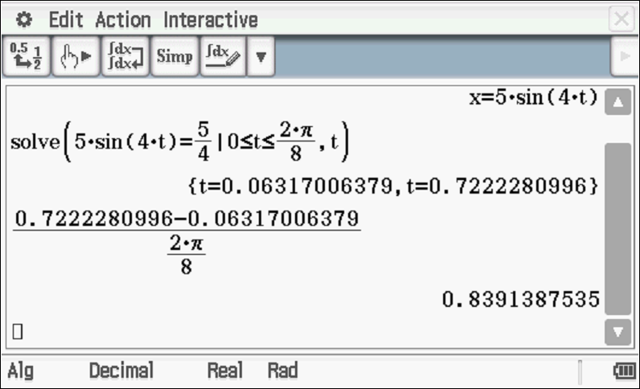

Specific behaviours
✓ determines times that x is one quarter of amplitude
✓ determines time of interval in one cycle or half cycle
✓ determines percentage

Question 19 (11 marks)

Consider a Cartesian equation of the plane and a vector equation of the line

Determine

(a) the position vector of the point of intersection of the line and the plane above.
(3 marks)

Solution
Specific behaviours
✓determines normal vector of plane
✓ solves for t
✓ determines position vector

(b) the length of the perpendicular from the origin to the line above to two decimal places
. (3 marks)

Solution
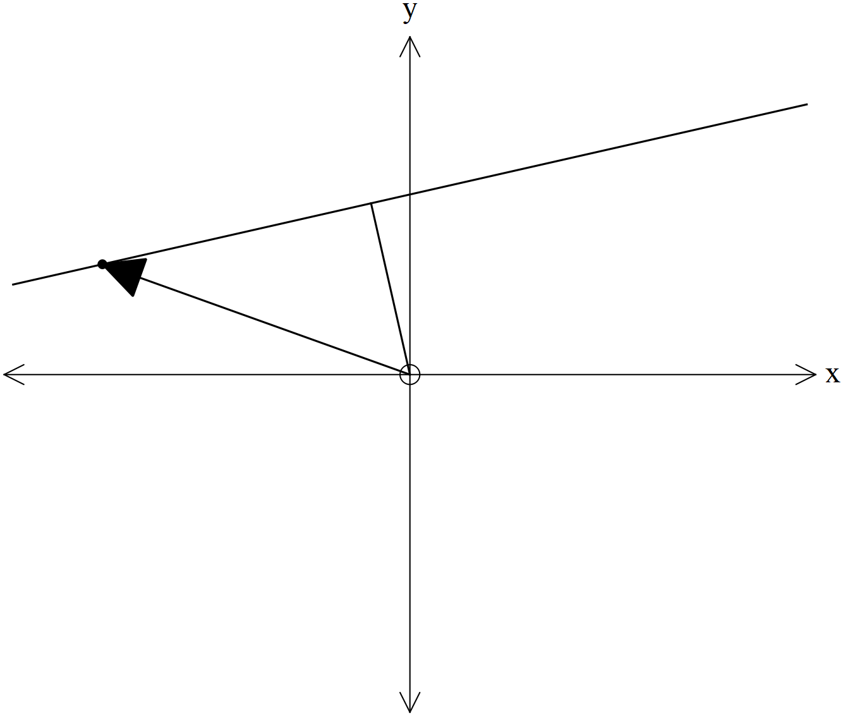
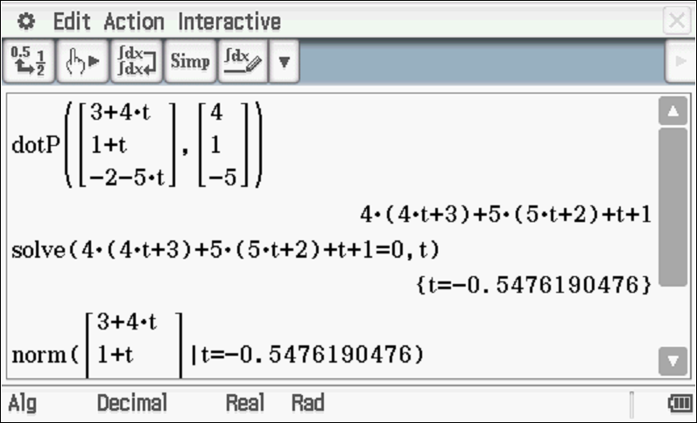
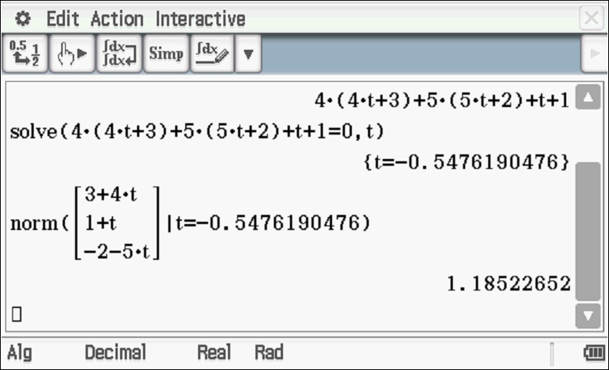
Specific behaviours
✓ uses dot product
✓ solves for t
✓ determines approx length of perpendicular

(c) a cartesian equation of a new plane which contains the line above and the origin.
(3 marks)

Solution
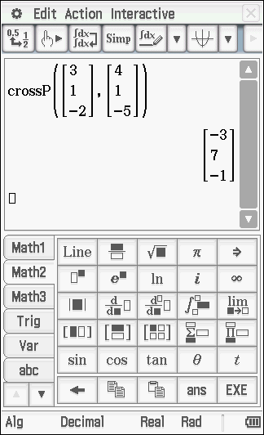

Specific behaviours
✓ identifies two vectors in required plane
✓ uses cross product to determine a normal vector
✓ determines cartesian equation of plane

(d) the acute angle between the planes from (a) & (c) above. (2 marks)

Solution
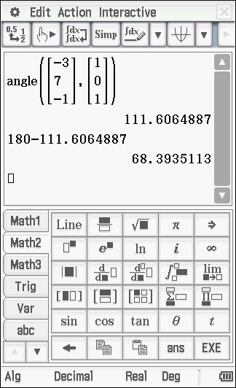

Specific behaviours
✓ identifies the two normal vectors
✓ determines acute angle

Question 20 (6 marks)

A policewoman moves along a straight road on a motorcycle with constant speed . Let = distance of policewoman from point on the road. A robber is on a second motorcycle moving on a roundabout of radius .The robber wishes to stay on a line of sight with the policewoman such that this line will always go through the centre of the roundabout as the policewoman approaches point on the road. The centre of the roundabout is units away from the road.

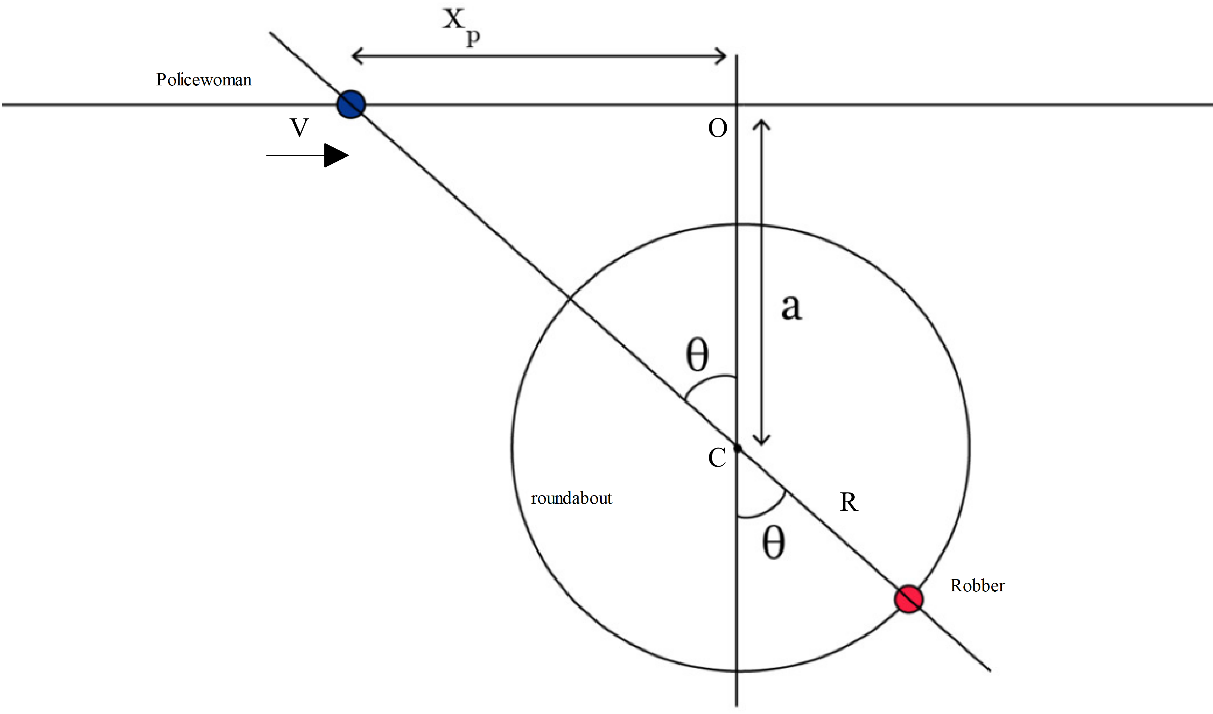Determine the speed on the roundabout that the robber must move at to maintain the line of sight with the policewoman trough the centre of the roundabout in terms of only.

Solution
Specific behaviours
✓ derives expression for tangent
✓ relates V to time derivative of
✓ derives relationship between V and
✓ derives expression for cosine
✓ derives expression between Robber’s speed and
✓ derives expression for Robber’s speed in stated variables only

Additional working space
Question number:

Additional working space
Question number:

Acknowledgements

